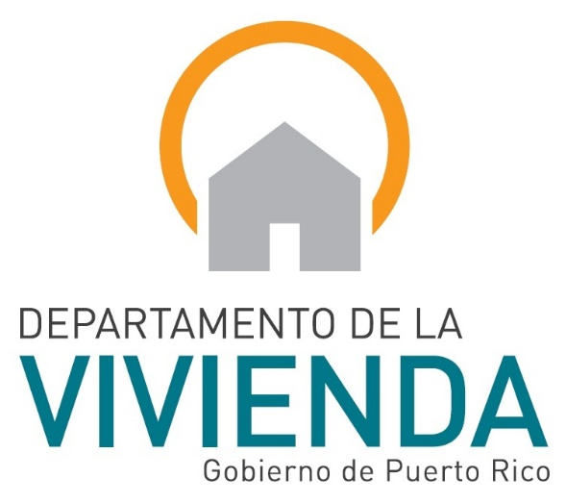
CLOSE-OUT DOCUMENT
Name Public Housing Development
CM/PM/Inspection Firm

PUERTO RICO PUBLIC HOUSING ADMINISTRATION

01 May 2017
Form AVP-500903
Rev. June 2017
Contractor

Project Final Brief

General Information
- Contractor:
- Designer:
- Program/Construction Manager:
- Administration Company:
- PRPHA Engineer Monitor:

Project Profile before Modernization
- Total Housing Units to be Modernized:
- Total Dwelling Building to be Modernized:
- Total Non-Dwelling Building to be Modernized:
- Parking spaces:
- Recreational Facilities:

Investment Costs
- Original Construction Cost:
- Approved Change Order Cost:
- Adjusted Construction Cost:
  - General Conditions:
  - Dwelling, Non-Dwelling Units:
  - Site:

Construction Data
- Start date:
- Construction time: days calendar
- Original Completion date:
- Additional time due to change orders : days
- Revised time of construction: days calendar
- Revised completion date:
- Modernized units: units
- Units in the process of modernization: units
- Modernized buildings: buildings
- Buildings in the process of modernization: buildings
- Work done and certified: $
- Percent of work done and certificated: %

Relocation
- Currently relocated families:
- Relocated families within the project:
- Relocated families outside the project:
- Units converted for special applications:

Direct Average Work Force
- Contractor:
- Construction/Program Manager:
- Designer / observer:

Work doing in Modernization
- Mitigation
  - Lead:

  - Asbestos:

- Site

- Housing units

- Administration Building and Community Center

- Others

Index
- Contract, Amendment and Change Orders Copy (CM1 and CM2)
- Final Acceptance Letter Copy
- Certificate and Release
- Relay of the Insurance Company
- "Affidavit" on No Debt With the Subcontractors and Suppliers
- Roof Warranty Bond
- Performance Bonds for Equipment, Labor and Materials
- Transfer of all the Guarantees to the PRPHA
- Relay of “Fondo del Seguro del Estado” Work Insurance
- Instructions for Equipment Operation
- Evidence of Delivery of "As-Built Plan"
- Relief of Revenues and Municipal Patents
- Relief of Internal Revenue Service
- ARPE/OGPe Construction and Use Permit
- Relay of the Puerto Rico Work Department
- Evidence of Contributions Payment to Puerto Rico Treasure Department
- Electrical Certifications
- Plumbing Certification
- Submittals Log and Evidence That Submitted Submittals Folder to Manager Agent
- Evidence of Closing Permit General Activities of Mitigation of Lead Base Painting Puerto Rico Environmental Quality Board (EQB)
- Evidence Submission to EQB for Closure General Permit for Management of Materials Containing Asbestos.
- Evidence Closure General Consolidated Permit
- Evidence of the closure for the national program of elimination of pollutants in discharges (NPDES)

